https://adcalves.files.wordpress.com/2014/06/ml-flowchart.jpg

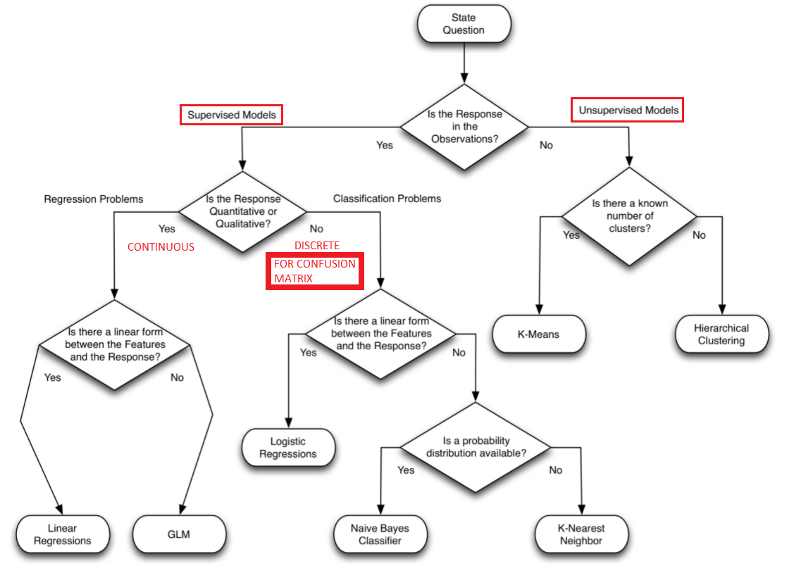

https://stackoverflow.com/questions/68963067/end-to-end-machine-learning-project-processes

